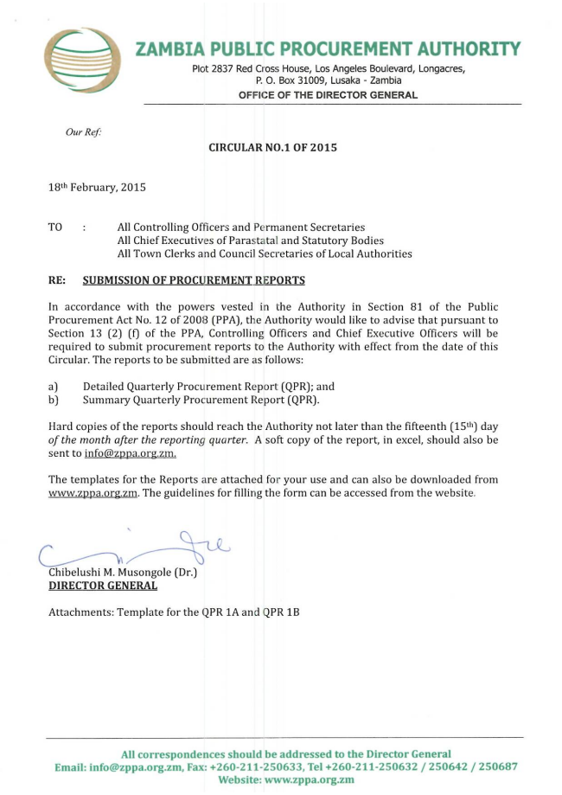
ZAMBIA PUBLIC PROCUREMENT AUTHORITY
Plot 2837 Red Cross House, Los Angeles Boulevard, Longacres, P. O. Box 31009, Lusaka - Zambia
OFFICE OF THE DIRECTOR GENERAL
Our Ref:
CIRCULAR NO.1 OF 2015
18th February, 2015
TO : All Controlling Officers and Permanent Secretaries
All Chief Executives of Parastatal and Statutory Bodies All Town Clerks and Council Secretaries of Local Authorities
RE: SUBMISSION OF PROCUREMENT REPORTS
In accordance with the powers vested in the Authority in Section 81 of the Public Procurement Act No. 12 of 2008 (PPA), the Authority would like to advise that pursuant to Section 13 (2) (f) of the PPA, Controlling Officers and Chief Executive Officers will be required to submit procurement reports to the Authority with effect from the date of this Circular. The reports to be submitted are as follows:
a) Detailed Quarterly Procurement Report (QPR; and b) Summary Quarterly Procurement Report (QPR).
Hard copies of the reports should reach the Authority not later than the fifteenth (15th) day of the month after the reporting quarter. A soft copy of the report, in excel, should also be
sent to infozppa.org..
The templates for the Reports are attached for your use and can also be downloaded from www.zppa.org.. The guidelines for filling the form can be accessed from the website.
Chibelushi M. Musongole (Dr.) DIRECTOR GENERAL
Attachments: Template for the QPR 1A and QPR 1B
All correspondences should be addressed to the Director General Email: infozppa.org., Fax. 260-211-250633, Tel 260-211-250632/25064.2250687 Website:www.zppa.org.zm

